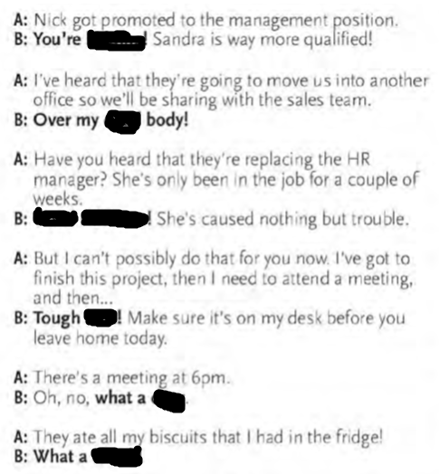

**Kidding , goodness me , luck , cheek , drag , dead,**

Where shall I put it ………………………….it anywhere

Have you taken decision I am having ……………………….thoughts

Do you remember his name It’s on the …………………of my tongue

It looks a bit expensive This is ………………………me

Can I have some more meat? ………………………….. yourself

Can I use your phoe ? Be my …………………………

I have got some bad news I am all …………………………

I can’t give you a hand Ok thanks all the…………….

My stomach hurts Serves you ……………………..

I am going to club ……………………yourself

Can you pass it I can’t be …………………….

I will become a superstar That will be the ………………

Where were you last night? ……………………..your own

business